|  |  |
| --- | --- |
| Team Id | PNT2022TMID41126 |
| Project Name | DemandEst - AI powered Food  Demand Forecaster |

Project Structure:

Create a Project folder which contains files as shown below

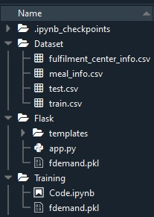

* We have three folders dataset, Flask and training.
* A python file called app.py for server side scipting.
* We need the model which is saved and the saved model in this content is **fdemand.pkl** ✓ Templates folder which contains home.html and upload.html files.
* Static folder which contains **css**folder which contains styles.css.